AI ASSISTANT LAB ASSIGNMENT 7.1
Name: S.Srija
2303A52412
Batch 44
Task Description 1 (Syntax Errors – Missing Parentheses in Print
Statement)
Task: Provide a Python snippet with a missing parenthesis in a print
statement (e.g., print "Hello"). Use AI to detect and fix the syntax
error.
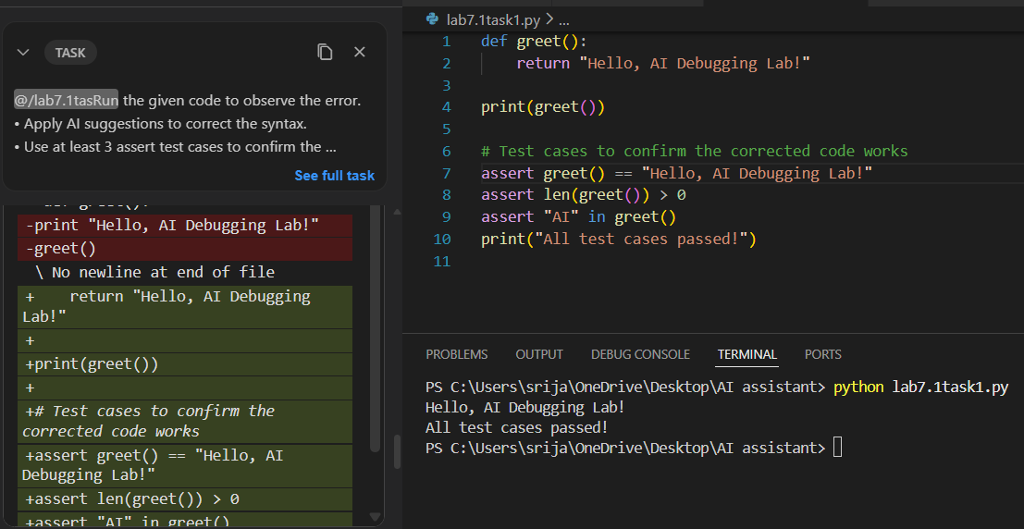
Task Description #2 (Incorrect condition in an If Statement)
# Bug: Using assignment (=) instead of comparison (==)
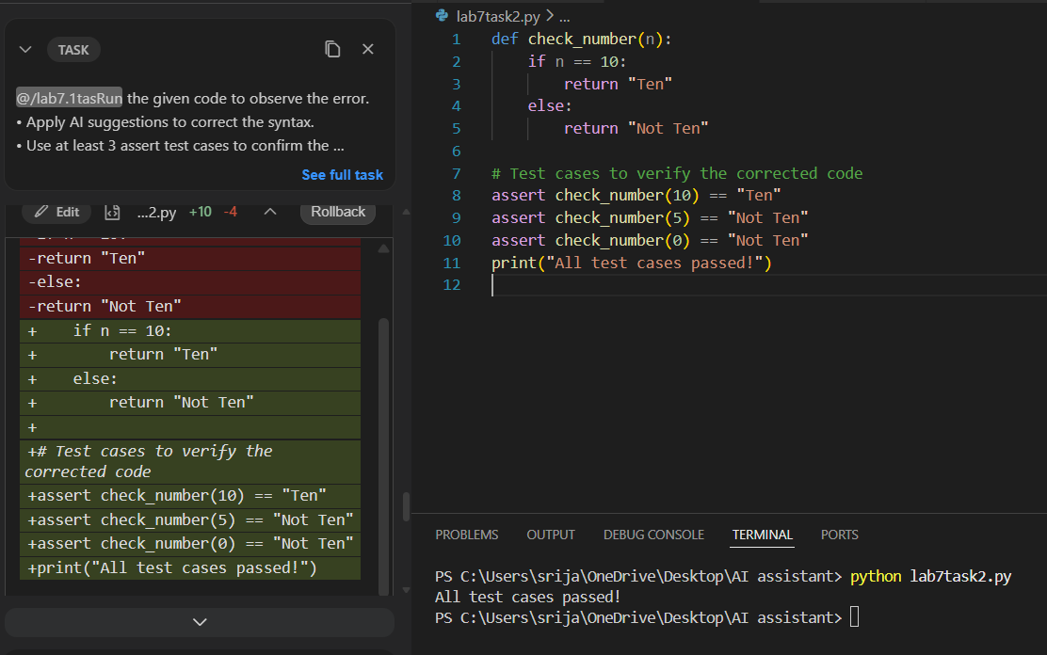
3) Task Description #3 (Runtime Error – File Not Found)
# Bug: Program crashes if file is missing
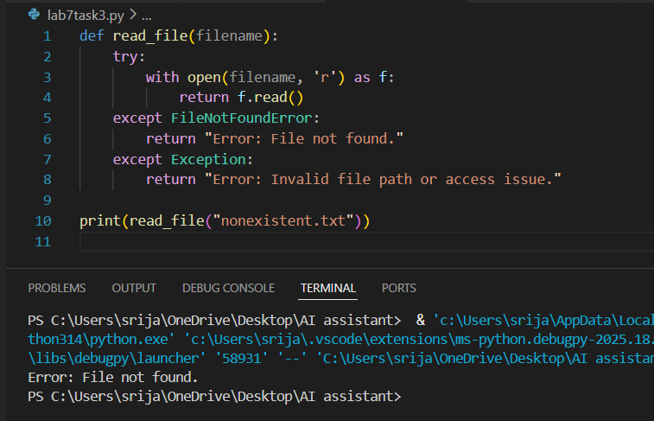
4) Task Description #4 (Calling a Non-Existent Method)
# Bug: Calling an undefined method

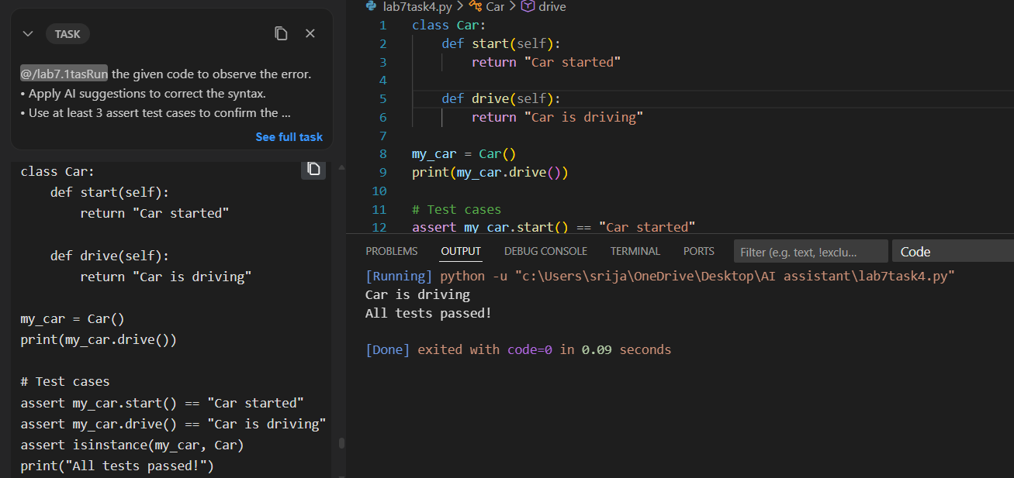
Task Description #5 (TypeError – Mixing Strings and Integers in
Addition)
# Bug: TypeError due to mixing string and integer
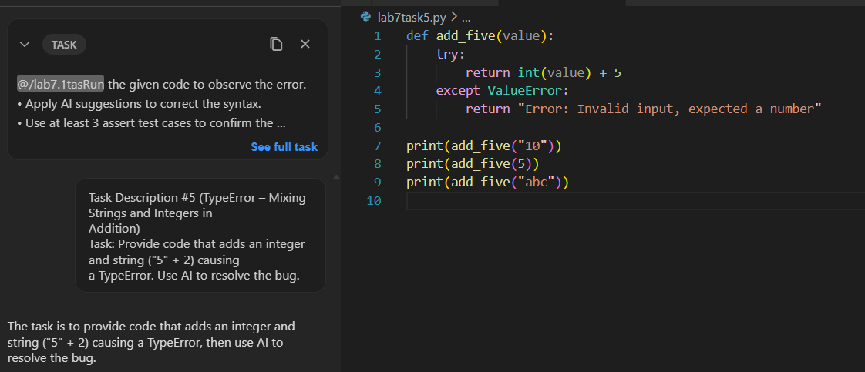
Output
